
DEPARTMENT OF COMPUTER SCIENCE AND ENGINEERING
2026 – 2027 (ODD SEMESTER)
CS2301 – INTERNET PROGRAMMING
Vehicle Service Booking System

1. TITLE
Development of a Dynamic Vehicle Service Booking System Using HTML, CSS, JavaScript, PHP and MySQL

2. ABSTRACT
A vehicle service booking system is a web-based platform that allows customers to view the servicing options offered by a vehicle service center and book an appointment online instead of visiting or calling the center in person.
The Vehicle Service Booking System, named DriveCare, is developed using HTML, CSS, JavaScript, PHP and MySQL. HTML is used to create the webpage structure, CSS is used for designing and styling, JavaScript is used for client-side interactivity, and PHP is used for server-side processing.
The website contains different sections such as Home, About, Services, Vehicle Types, Book a Service, Testimonials and Contact. A dynamic booking form is implemented using PHP and MySQL. Customers can enter their name, email, phone number, vehicle type, vehicle number, service required, preferred date and time. The submitted information is validated by PHP and stored in the MySQL database. An admin page is also provided to view and update the status of each booking, demonstrating data management as an additional dynamic feature.
The project demonstrates the practical integration of front-end development, client-side scripting, server-side processing and database connectivity to create a functional dynamic vehicle service booking website.

3. INTRODUCTION
Booking a vehicle service traditionally requires a customer to call or personally visit the service center, which can be time-consuming for both the customer and the service staff. A web-based booking system provides an organised and convenient alternative that allows appointments to be scheduled at any time.
The website presents the services offered by the service center, the types of vehicles handled, and allows a customer to submit a service request through an online form. It highlights the use of front-end technologies for presentation, server-side scripting for processing form data, and a relational database for persistently storing booking records.
The website is developed using HTML, CSS and JavaScript on the front end. PHP is used for server-side processing, while MySQL is used to store the service bookings submitted by customers.

4. METHODOLOGY / APPROACH
The vehicle service booking website is developed using a combination of front-end and back-end technologies.

4.1 Technologies Used
HTML
HTML is used to create the structure of the website. It is used to define headings, sections, navigation links, forms, buttons, paragraphs and other webpage elements.
CSS
CSS is used to design and style the website. It controls:
- Page layout
- Colors
- Fonts
- Navigation bar
- Buttons and cards
- Booking form
- Spacing
- Responsive design
JavaScript
JavaScript is used to provide client-side interactivity. It is used for navigation highlighting, mobile menu toggling, and validating the booking form (name, phone number and date) before it is submitted to the server.
PHP
PHP is used for server-side processing. In this project, PHP processes the booking form submitted by customers, re-validates the data, and communicates with the MySQL database. PHP is also used to build the admin page that lists and updates bookings.
MySQL
MySQL is used to store the information submitted through the booking form in a table named bookings.
XAMPP
XAMPP is used as the local development environment for running Apache, PHP and MySQL.

4.2 Website Structure

VEHICLE SERVICE BOOKING SYSTEM
|
┌───────────┴───────────┐
FRONT END BACK END
| |
HTML + CSS + PHP
JavaScript |
| MySQL
|
├── Home
├── About
├── Services
├── Vehicle Types
├── Book a Service
├── Testimonials
├── Contact
└── Admin (booking management)

4.3 Website Workflow
A visitor opens the website, browses the Services and Vehicle Types sections, and then fills the Book a Service form. The form data is sent to the PHP server, validated, and stored in the MySQL database. The service center staff can log in to the admin page to view submitted bookings and update their status.

4.4 Home Section
The Home section introduces the service center to the visitor.
Content
- DriveCare
- Reliable Vehicle Service, Booked in Minutes
The Home section provides navigation links to the different sections of the website and a call-to-action button that leads to the booking form.

4.5 About Section
The About section describes DriveCare as a vehicle service center that offers doorstep and in-garage servicing for cars and bikes, and explains that appointments booked online are stored in the database so service advisors can prepare in advance.

4.6 Services Section
The Services section lists the services offered:
- Oil & Filter Change
- Tyre & Wheel Care
- General Repair
- Battery & Electrical
- Car Wash & Detailing
- Periodic Maintenance

4.7 Vehicle Types Section
The Vehicle Types section lists the categories of vehicles handled:
- Two-Wheeler
- Hatchback / Sedan
- SUV
- Commercial Vehicle

4.8 Book a Service Section (Dynamic Form)
The Book a Service section allows a visitor to schedule an appointment. The booking form contains:
- Full Name
- Email
- Phone Number
- Vehicle Type
- Vehicle Number
- Service Required
- Preferred Date
- Preferred Time
- Additional Notes (optional)
The visitor enters the required information and submits the form. The information is sent to the PHP server for processing. PHP validates the submitted information and stores it in the MySQL database. A confirmation or error message is then displayed back on the page.

4.9 Testimonials Section
The Testimonials section displays feedback from customers who have used the online booking feature.

4.10 Contact Section
The Contact section displays the address, phone number, email address and working hours of the service center.

4.11 Database Design
A MySQL database named vehicle_service_booking is used for the website.
A table named bookings is used to store the details submitted through the booking form.
Table Structure
Column | Type | Description
booking_id | INT (Primary Key, Auto Increment) | Unique identifier for each booking
customer_name | VARCHAR(100) | Name of the customer
email | VARCHAR(100) | Customer's email address
phone | VARCHAR(15) | Customer's phone number
vehicle_type | VARCHAR(50) | Type of vehicle
vehicle_number | VARCHAR(20) | Registration number of the vehicle
service_type | VARCHAR(100) | Service requested
service_date | DATE | Preferred service date
service_time | VARCHAR(20) | Preferred service time slot
message | TEXT | Additional notes from the customer
status | VARCHAR(20) | Booking status (Pending / Confirmed / Completed / Cancelled)
created_at | TIMESTAMP | Date and time the booking was created

4.12 Booking Form Workflow
Visitor enters booking details
|
Submit
|
process_booking.php
|
Validate information
|
Valid information?
/ \
Yes No
| |
Insert into Display
MySQL Error
|
Success Message

5. IMPLEMENTATION CODE

5.1 Project Folder Structure
The project is stored inside the XAMPP htdocs directory.
vehicle-service-booking/
├── index.php
├── process_booking.php
├── admin.php
├── db.php
├── database.sql
├── README.md
├── css/
│ └── style.css
├── js/
│ └── script.js
└── images/

5.2 Database Connection – db.php
<?php
$servername = "localhost";
$username = "root";
$password = "";
$database = "vehicle_service_booking";

$conn = new mysqli(
$servername,
$username,
$password,
$database
);

if ($conn->connect_error) {
die("Database connection failed: " . $conn->connect_error);
}
$conn->set_charset("utf8mb4");
?>
Explanation: The db.php file establishes the connection between PHP and the MySQL database. The database used by the project is vehicle_service_booking.

5.3 Booking Form (excerpt from index.php)
<form id="bookingForm" class="booking-form" action="process_booking.php" method="POST">
<input type="text" id="customer_name" name="customer_name" required>
<input type="email" id="email" name="email" required>
<input type="text" id="phone" name="phone" maxlength="10" required>
<select id="vehicle_type" name="vehicle_type" required> ... </select>
<input type="text" id="vehicle_number" name="vehicle_number" required>
<select id="service_type" name="service_type" required> ... </select>
<input type="date" id="service_date" name="service_date" required>
<select id="service_time" name="service_time" required> ... </select>
<textarea id="message" name="message"></textarea>
<button type="submit" class="btn">Confirm Booking</button>
</form>

5.4 Server-Side Processing – process_booking.php
<?php
session_start();
include "db.php";

if ($_SERVER["REQUEST_METHOD"] == "POST") {
$customer_name = trim($_POST["customer_name"]);
$email = trim($_POST["email"]);
$phone = trim($_POST["phone"]);
$vehicle_type = trim($_POST["vehicle_type"]);
$vehicle_number = trim($_POST["vehicle_number"]);
$service_type = trim($_POST["service_type"]);
$service_date = trim($_POST["service_date"]);
$service_time = trim($_POST["service_time"]);
$message = trim($_POST["message"]);

if (empty($customer_name) || empty($email) || empty($phone) ||
empty($vehicle_type) || empty($vehicle_number) ||
empty($service_type) || empty($service_date) || empty($service_time)) {
// redirect with "Please fill in all required fields."
}

if (!filter_var($email, FILTER_VALIDATE_EMAIL)) {
// redirect with "Please enter a valid email address."
}

if (!preg_match('/^[0-9]{10}$/', $phone)) {
// redirect with "Please enter a valid 10-digit phone number."
}

$sql = "INSERT INTO bookings
(customer_name, email, phone, vehicle_type, vehicle_number,
service_type, service_date, service_time, message)
VALUES (?, ?, ?, ?, ?, ?, ?, ?, ?)";
$stmt = $conn->prepare($sql);
$stmt->bind_param("sssssssss", $customer_name, $email, $phone,
$vehicle_type, $vehicle_number, $service_type,
$service_date, $service_time, $message);

if ($stmt->execute()) {
// redirect with "Your service has been booked successfully!"
}
$stmt->close();
$conn->close();
}
?>
Explanation: The form data is retrieved using $_POST, validated for empty fields, a valid email format, a 10-digit phone number and a future service date. A prepared statement is used to insert the validated data into the bookings table, which prevents SQL injection. A status message is then passed back to index.php and displayed to the visitor.

5.5 Admin Page – admin.php
<?php
include "db.php";

if (isset($_POST['update_status'])) {
$id = intval($_POST['booking_id']);
$status = $_POST['status'];
$stmt = $conn->prepare("UPDATE bookings SET status = ? WHERE booking_id = ?");
$stmt->bind_param("si", $status, $id);
$stmt->execute();
$stmt->close();
header("Location: admin.php");
exit();
}

$result = $conn->query("SELECT * FROM bookings ORDER BY service_date ASC, service_time ASC");
?>
Explanation: The admin page reads every row from the bookings table and displays it in an HTML table. It also allows the service center staff to update a booking's status (Pending, Confirmed, Completed or Cancelled), demonstrating both retrieval and update operations on the database.

5.6 JavaScript Implementation
document.addEventListener("DOMContentLoaded", function () {
const links = document.querySelectorAll("nav ul li a");
links.forEach(function (link) {
link.addEventListener("click", function () {
links.forEach(function (item) {
item.classList.remove("active");
});
this.classList.add("active");
});
});

const bookingForm = document.getElementById("bookingForm");
if (bookingForm) {
bookingForm.addEventListener("submit", function (e) {
// validate name, phone number and date before submitting
});
}
});
Explanation: The JavaScript code highlights the active navigation link, toggles the mobile menu, and validates the customer's name, phone number and selected date on the client side before the booking form is submitted to the server.

5.7 CSS Implementation
body {
margin: 0;
font-family: 'Segoe UI', Arial, sans-serif;
line-height: 1.6;
}
section {
padding: 70px 10%;
}
.booking-form {
max-width: 700px;
margin: 0 auto;
background: #ffffff;
padding: 40px;
border-radius: 8px;
}
CSS is used throughout the website for layout, styling, cards, the booking form, navigation and responsive design.

5.8 Main Website – index.php
The index.php file acts as the main webpage. It contains:
- Navigation bar
- Home section
- About section
- Services section
- Vehicle Types section
- Book a Service section
- Testimonials section
- Contact section
- Footer
The page connects to the CSS and JavaScript files using:
<link rel="stylesheet" href="css/style.css">
<script src="js/script.js"></script>
The booking form is connected to: <form action="process_booking.php" method="POST">

6. SCREENSHOTS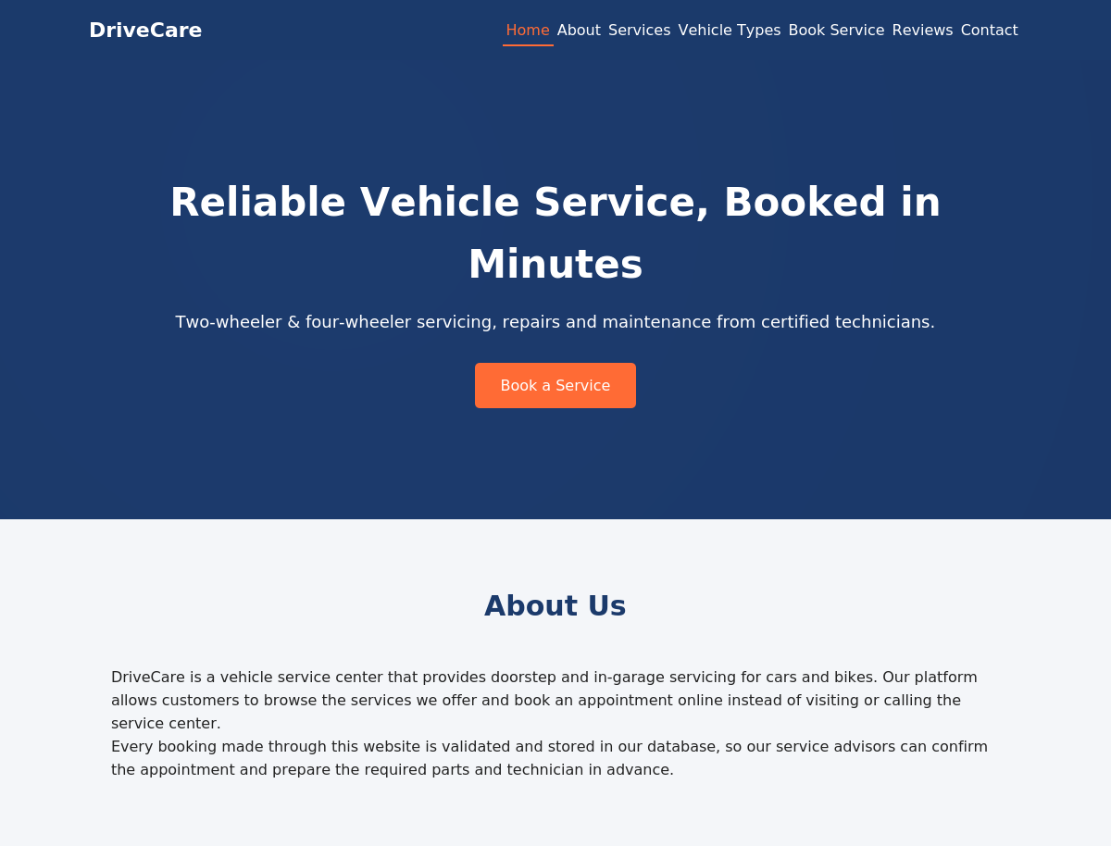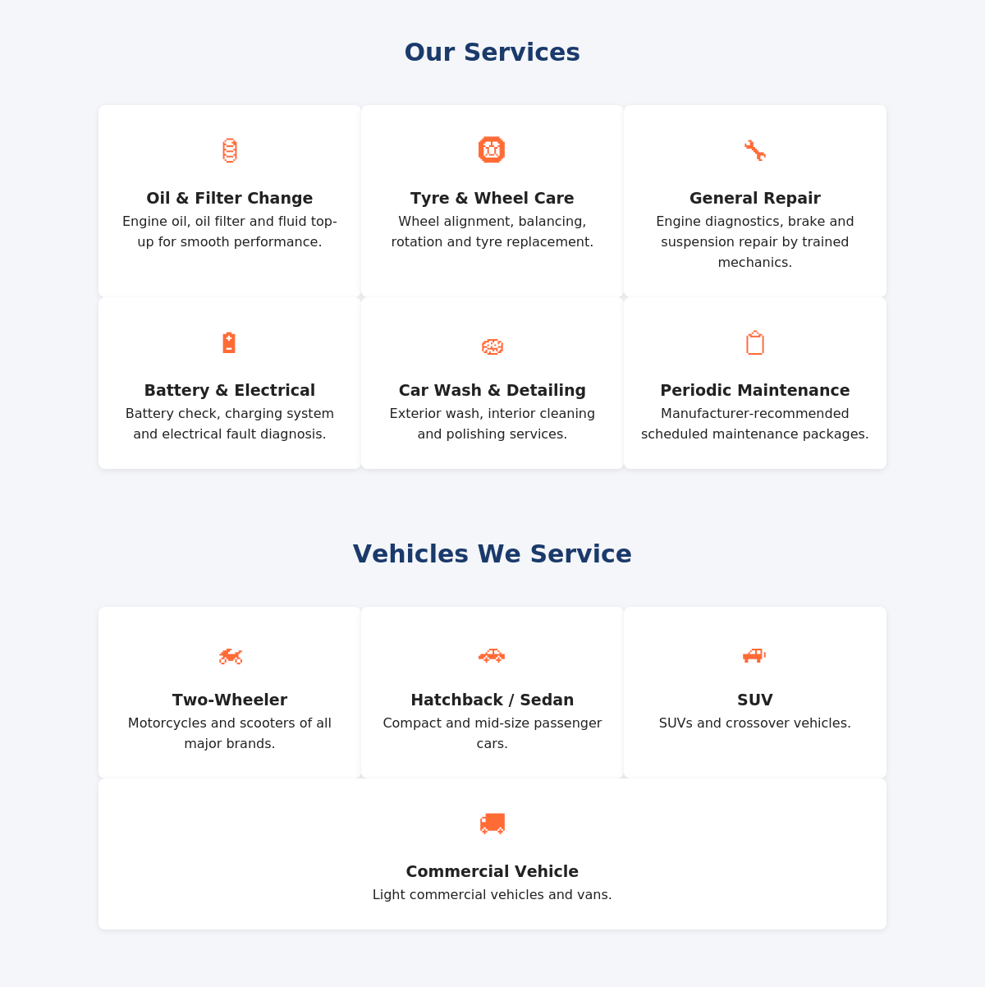

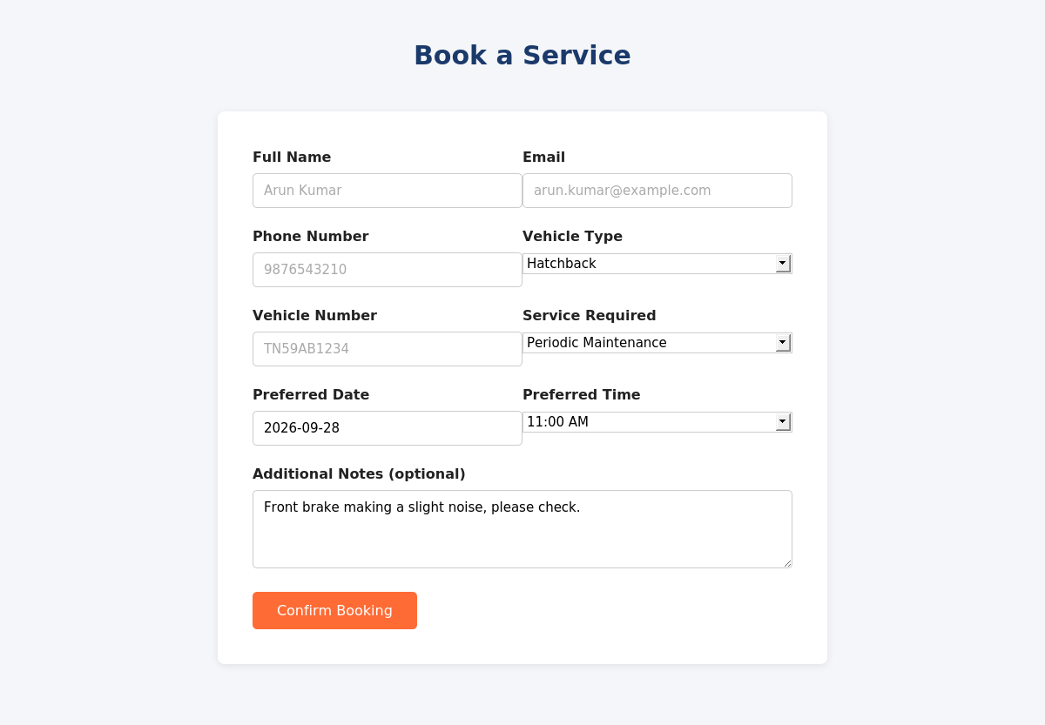

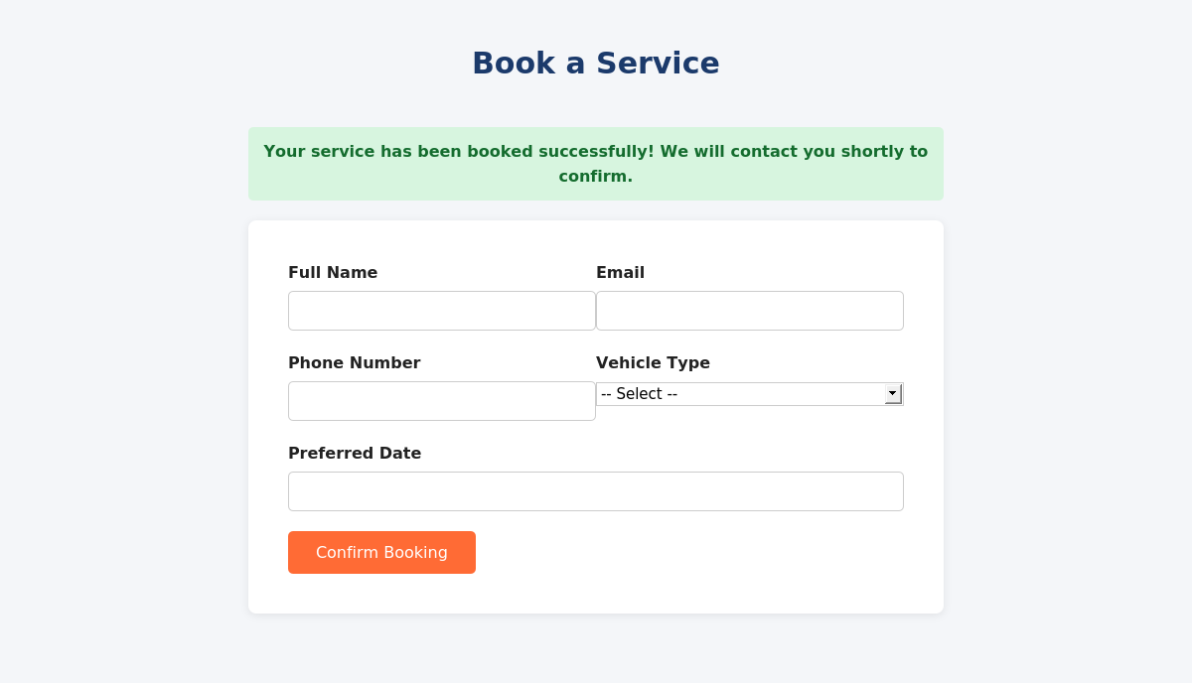

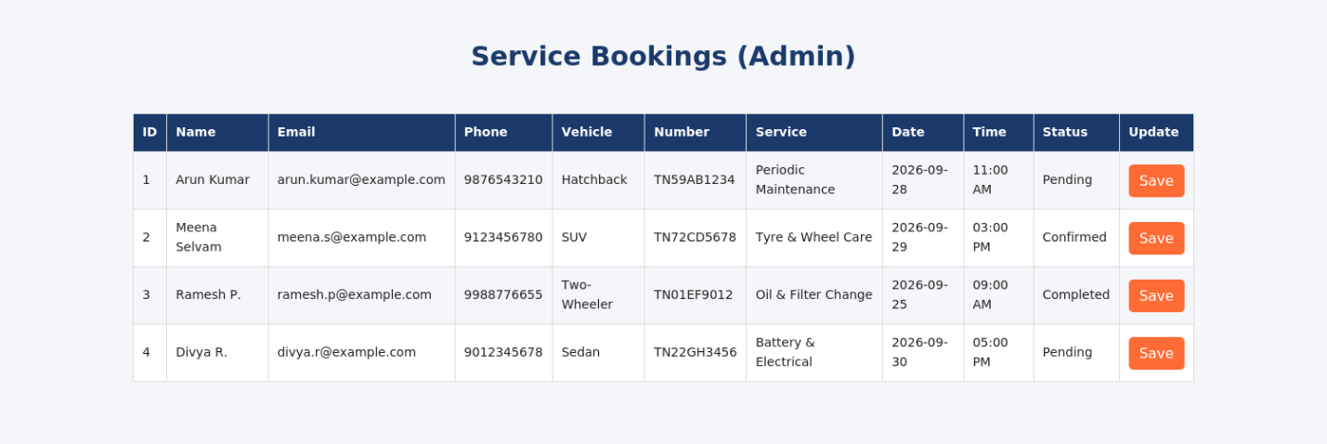

9. REFERENCES

W3Schools. HTML Tutorial. https://www.w3schools.com/html/

W3Schools. JavaScript Tutorial. https://www.w3schools.com/js/

W3Schools. PHP Tutorial. https://www.w3schools.com/php/

Mozilla Developer Network (MDN). HTML, CSS and JavaScript documentation. https://developer.mozilla.org/

PHP Manual. The PHP Group. https://www.php.net/manual/en/

MySQL 8.0 Reference Manual. Oracle Corporation. https://dev.mysql.com/doc/refman/8.0/en/

MySQLi Extension Documentation (Prepared Statements). https://www.php.net/manual/en/book.mysqli.php

Apache Friends. XAMPP Documentation. https://www.apachefriends.org/docs//

7. CONCLUSION
The website provides an organised online platform for customers to view the services offered by a vehicle service center and to book an appointment without visiting or calling the center. The front end of the website was developed using HTML and CSS, while JavaScript was used to provide client-side interactivity and form validation.
PHP was implemented for server-side processing of the booking form, and MySQL was used to store the submitted booking information. An admin page was also implemented to read and update booking records, demonstrating full database interaction. The integration of these technologies demonstrates the practical application of Internet Programming concepts.
The project provided practical experience in developing a responsive webpage, implementing client-side interaction, processing forms using PHP, and connecting a web application with a MySQL database.
Thus, the dynamic Vehicle Service Booking System successfully demonstrates the use of Internet Programming technologies to create a functional and database-connected web application.

